**EXTRA CURRICULAR ACTIVITY PROJECT**

**FASTELEC – TRAVEL ELECTRIFIED**

*Made under the guidance of*

**Prof. Jayakumar S**

*By*

**Tushar Kumar B P – 19BIT0358**

**Anand Kumar – 19BEI0105**

**ABSTRACT**

Nowadays, we have been seeing electric cars that are roaming around everywhere. Electric cars require electricity as fuel. There are some power stations available for electric cars, from where you can get the battery charged up and then continue to move on. But what if there are no means to track the amount you’re supposed to pay for the cars you own. This is where **FastElec** comes into action.

**INTRODUCTION**

**FastElec** is a website that allows the user to pay for the amount of electricity the user has made use of, to charge up his/her hybrid/electric car using a Supercharger. This website will also help the user to keep track of the amount that he is supposed to pay for each vehicle and then pay for that particular car.

**TECHNOLOGIES USED**

**HTML –** The basic markup language used for making the main components of the website.

**CSS –** The language that is used for designing and beautifying the frontend of the webpage/website.

**JavaScript –** A programming language used for handling some functions used for the website. In this case, we made use of random function for generating random numbers for the payment receipts; making sure that all the fields are entered properly etc.

**PHP –** This language was used for the server-side scripting of maintaining the sessions of the logins and inserting information into the table of the database.

**VS Code –** The IDE that contains multiple extensions was used for handling all sorts of files and making sure that the coding experience was efficient.

**MySQL –** This was used for maintaining the database **FastElec.** **phpMyAdmin** proved to be an amazing tool to handle the database.

**Bootstrap** – This framework was used to maintain the interface in a proper manner and beautifying the front-end.

**SOME SAMPLE CODES**

**index.php**

<?php

session_start();

?>

<html>

  <head>

    <title> FastElec </title>

  </head>

  <link rel="stylesheet" type = "text/css" href ="css/bootstrap.min.css">

  <link rel="stylesheet" type = "text/css" href ="css/index.css">

  <body>

    <nav class="navbar navbar-inverse navbar-fixed-top navigation-clean-search" role="navigation">

      <div class="container">

        <div class="navbar-header">

          <button type="button" class="navbar-toggle collapsed" data-toggle="collapse" data-target="#myNavbar">

            <span class="sr-only">Toggle navigation</span>

            <span class="icon-bar"></span>

            <span class="icon-bar"></span>

            <span class="icon-bar"></span>

          </button>

          <a class="navbar-brand" href="index.php">   <a class="navbar-brand" href="index.php"> <img src="car.png" width="150" align="left" style="margin-top=0;padding-top=0;filter: drop-shadow(0px 0px 20px black);"> </a>

 </a>

        </div>

        <div class="collapse navbar-collapse " id="myNavbar">

          <ul class="nav navbar-nav">

            <li class="active" ><a href="index.php">Home</a></li>

            <li><a href="contactus.php">Contact Us</a></li>

          </ul>

<?php

if(isset($_SESSION['login_user1'])){

?>

          <ul class="nav navbar-nav navbar-right">

            <li><a href="#"><span class="glyphicon glyphicon-user"></span> Welcome <?php echo $_SESSION['login_user1']; ?> </a></li>

            <li><a href="logout_m.php"></span> Log Out </a></li>

          </ul>

<?php

}

else if (isset($_SESSION['login_user2'])) {

  ?>

           <ul class="nav navbar-nav navbar-right">

            <li><a href="#"> Welcome <?php echo $_SESSION['login_user2']; ?> </a></li>

             </a></li>

            <li><a href="logout_u.php"> Log Out </a></li>

          </ul>

  <?php

}

else {

  ?>

<?php

}

?>

       </div>

      </div>

    </nav>

<style>

  .welcome{

    color: cadetblue;

    font-style: bold;

    font-size: 50px;

    padding-top: 30px;

    font-family: 'Gill Sans', 'Gill Sans MT', Calibri, 'Trebuchet MS', sans-serif;

  }

  .fastelec{

  font-size: 200px;

  font-family:'Gill Sans', 'Gill Sans MT', Calibri, 'Trebuchet MS', sans-serif;

  }

  .fastelec:hover{

  color:aqua;

  }

</style>

<center><p class="welcome">Welcome to</p><p class="fastelec">FastElec</p></center>

  <br>

  <br><br>

</div>

</header>

    <br>

    <center><a class="btn btn-success btn-lg" href="customerlogin.php" role="button" > Login </a></center>

<br><br>

</body>

</html>

**homepage.php**

<?php

session_start();

if(!isset($_SESSION['login_user2'])){

header("location: customerlogin.php");

}

?>

<html>

  <head>

    <title> FastElec </title>

  </head>

  <link rel="stylesheet" type = "text/css" href ="css/homepage.css">

  <link rel="stylesheet" type = "text/css" href ="css/bootstrap.min.css">

  <script type="text/javascript" src="js/jquery.min.js"></script>

  <script type="text/javascript" src="js/bootstrap.min.js"></script>

  <body>

    <button onclick="topFunction()" id="myBtn" title="Go to top">

      <span class="glyphicon glyphicon-chevron-up"></span>

    </button>

    <script type="text/javascript">

      window.onscroll = function()

      {

        scrollFunction()

      };

      function scrollFunction(){

        if (document.body.scrollTop > 20 || document.documentElement.scrollTop > 20) {

          document.getElementById("myBtn").style.display = "block";

        } else {

          document.getElementById("myBtn").style.display = "none";

        }

      }

      function topFunction() {

        document.body.scrollTop = 0;

        document.documentElement.scrollTop = 0;

      }

    </script>

    <nav class="navbar navbar-inverse navbar-fixed-top navigation-clean-search" role="navigation">

      <div class="container">

        <div class="navbar-header">

          <button type="button" class="navbar-toggle collapsed" data-toggle="collapse" data-target="#myNavbar">

            <span class="sr-only">Toggle navigation</span>

            <span class="icon-bar"></span>

            <span class="icon-bar"></span>

            <span class="icon-bar"></span>

          </button>

          <a class="navbar-brand" href="index.php"> <img src="car.png" width="150" align="left" style="margin-top=0;padding-top=0;filter: drop-shadow(0px 0px 20px black);"> </a>

        </div>

        <div class="collapse navbar-collapse " id="myNavbar">

          <ul class="nav navbar-nav">

            <li><a href="index.php">Home</a></li>

            <li><a href="contactus.php">Contact Us</a></li>

          </ul>

<?php

if(isset($_SESSION['login_user1'])){

?>

<?php

}

else if (isset($_SESSION['login_user2'])) {

  ?>

           <ul class="nav navbar-nav navbar-right">

            <li><a href="#"> Welcome <?php echo $_SESSION['login_user2']; ?> </a></li>

            </a></li>

            <li><a href="logout_u.php"> Log Out </a></li>

          </ul>

  <?php

}

else {

  ?>

<?php

}

?>

        </div>

      </div>

    </nav>

      <center><strong><a href="add_cars.php"><button id="cars">Check your cars</button></a></strong><a href="COD.php"><strong><button id="pay">Pay Immmediately</button></strong><a href="about.php"><strong><button id="about">About us</button></strong><</a></center>

</div>

</div>

</body>

</html>

**login_u.php**

<?php

session_start();

$error='';

if (isset($_POST['submit'])) {

if (empty($_POST['username']) || empty($_POST['password'])) {

$error = "Username or Password is invalid";

}

else

{

// Define $username and $password

$username=$_POST['username'];

$password=$_POST['password'];

// Establishing Connection with Server by passing server_name, user_id and password as a parameter

require 'connection.php';

$conn = Connect();

// SQL query to fetch information of registerd users and finds user match.

$query = "SELECT username, password FROM CUSTOMER WHERE username=? AND password=? LIMIT 1";

// To protect MySQL injection for Security purpose

$stmt = $conn->prepare($query);

$stmt -> bind_param("ss", $username, $password);

$stmt -> execute();

$stmt -> bind_result($username, $password);

$stmt -> store_result();

if ($stmt->fetch())

{

    $_SESSION['login_user2']=$username; // Initializing Session

    header("location: homepage.php"); // Redirecting To Other Page

} else {

$error = "Username or Password is invalid";

}

mysqli_close($conn); // Closing Connection

}

}

?>

**logout.php**

<?php

session_start();

if(session_destroy()) // Destroying All Sessions

{

header("Location: customerlogin.php"); // Redirecting To Home Page

}

?>

**SNAPSHOTS**

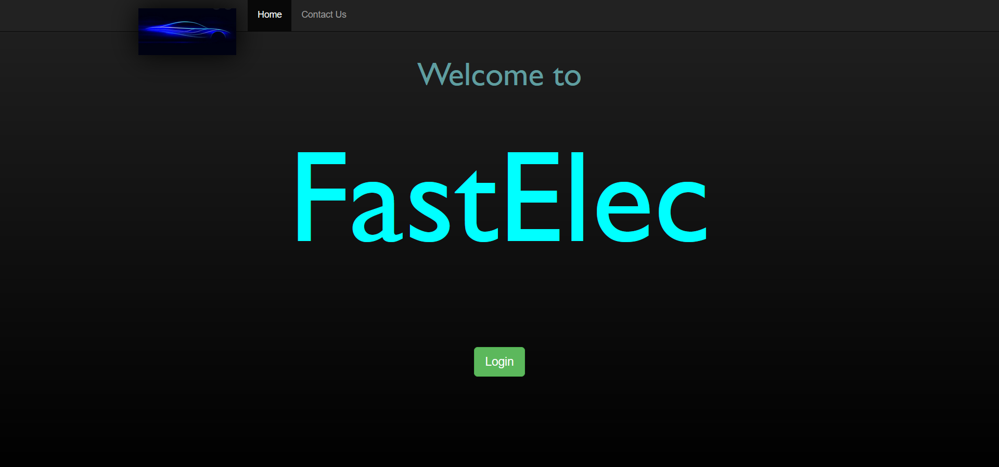

**index.php**

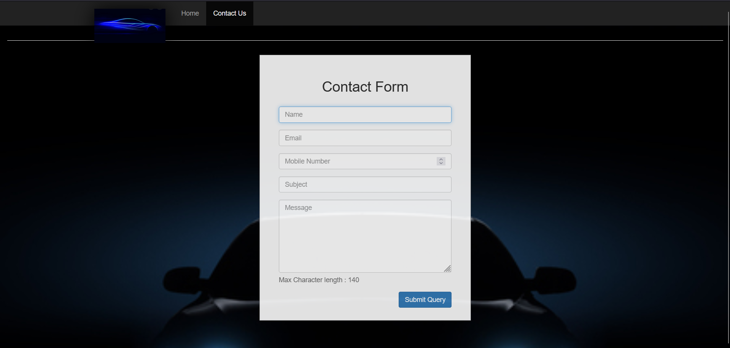

**contactus.php**

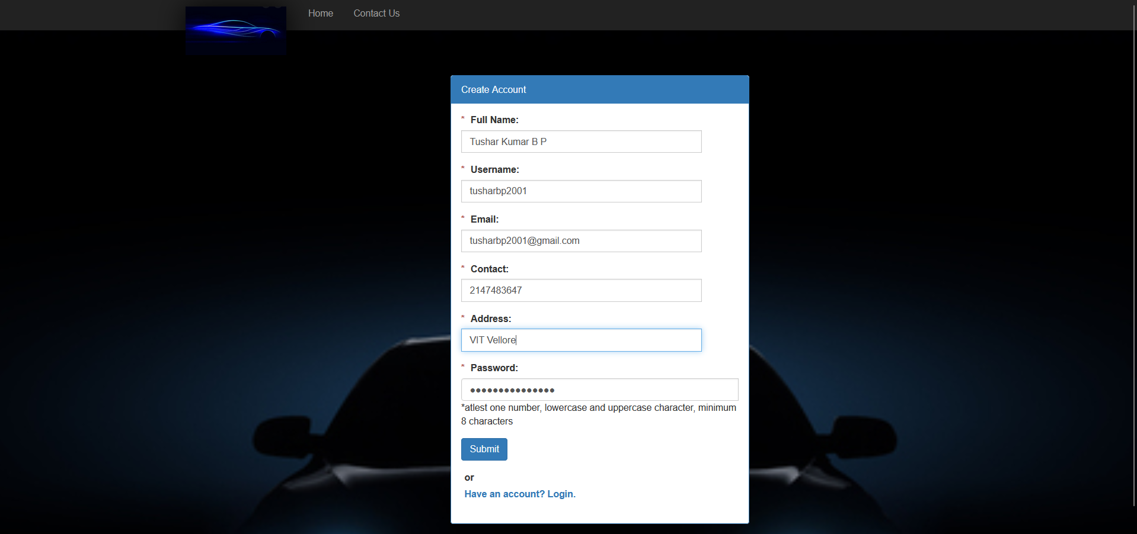

**customersignup.php**

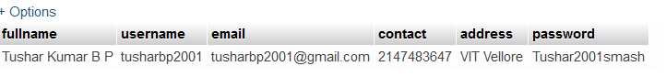

**Row submitted in phpMyAdmin**

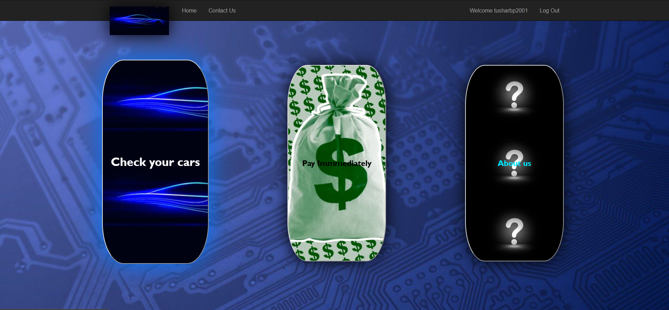

**homepage.php**

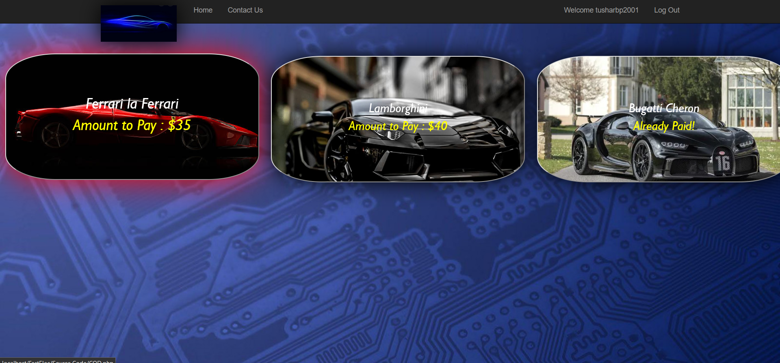

**cars.php**

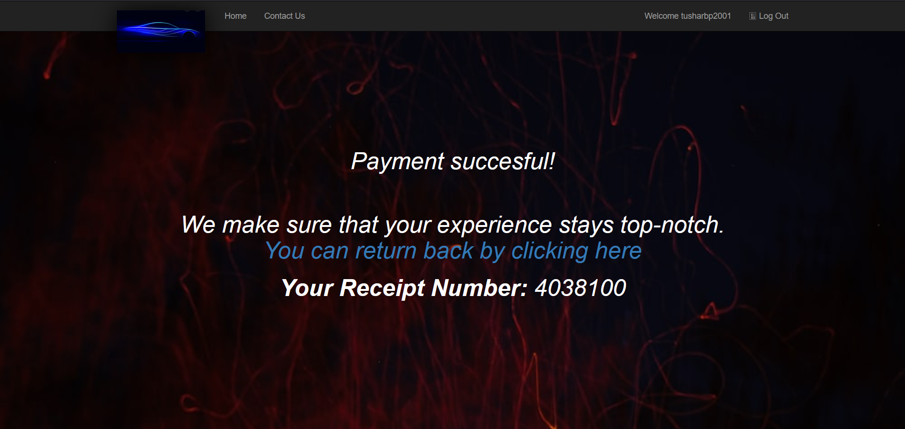

**COD.php with randomly generating receipt number**

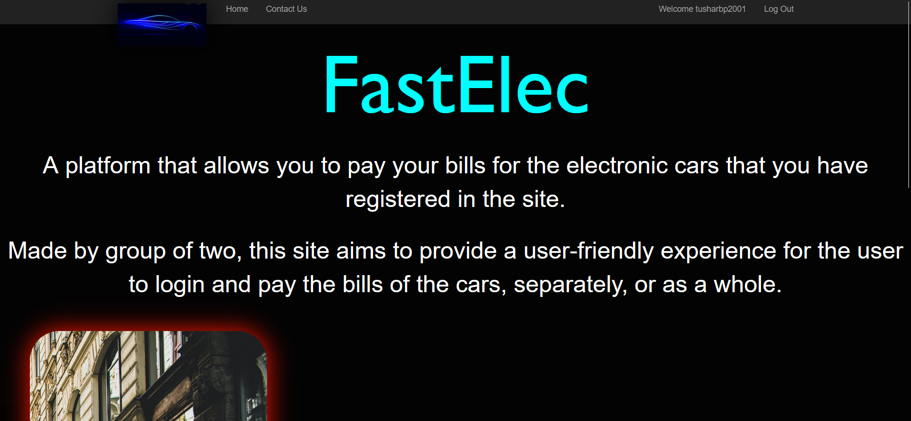

**about.php**

**LINK TO GITHUB**

**https://github.com/tushar2001-chiro/Fastelec**